
Faculty of Engineering and Technology
Computer Science Department
Data Science and Analytics - COMP4381

DelayGuide: A Predictive Analytics System for Flight Delay Analysis and Prediction

Prepared by:
Raheeq Mousa - 1220515
Aya Abd-Alkarim - 1220020
Zaid Mousa - 1221833

Instructor: Ahmad Sabbah
Abstract
Flight delays are a common problem in global air travel and they cause higher costs for airlines and inconvenience for passengers. This project builds a full data science pipeline to study and predict flight delays using data from airports, and weather conditions across at least five countries. The data is collected from reliable aviation sources, cleaned, and processed to create a dataset with more than 1000 records and at least 15 important features such as flight schedules, airport information, and weather factors.
A machine learning approach is used to predict whether a flight will be delayed or not (binary classification). Different models will be tested and compared to find the best performing one. The main goal is not only to build a prediction model but also to understand the key factors that cause delays. The results help show how data science can be used to improve planning and decision-making in the airline industry.

Contents
1. Introduction 1
2. Background 2
2.1 The Nature and Propagation of Flight Delays. 2
2.2 Causes of Flight Delays. 2
2.3 Machine Learning in Flight Delay Prediction. 3
2.4 Challenges in Building Predictive Models. 3
3. Domain explanation 4
4. Algorithm Background 5
4.1 Logistic Regression 5
4.2 Decision Tree 6
4.3 Random Forest 6
4.4 XGBoost 7
4.5 Model Evaluation Metrics 7
4.6 Handling Class Imbalance Using Class Weights 8
5. Literature Review 8
5.1 Overview of Selected Studies 8
5.2 Comparative Summary Table 12
6. References 14

Acronyms and Abbreviations

ML Machine Learning
KNN K-Nearest Neighbor
SVM Support Vector Machine
RF Random Forest
DT Decision Tree
LR Logistic Regression
GBT Gradient Boosted Tree
NB Naïve Bayes
GNB Gaussian Naïve Bayes
XGBoost Extreme Gradient Boosting
SMOTE Synthetic Minority Over-sampling Technique
SHAP SHapley Additive exPlanations
ANN Artificial Neural Network
BTS Bureau of Transportation Statistics
IATA International Air Transport Association
ADS-B Automatic Dependent Surveillance–Broadcast
ROC-AUC Receiver Operating Characteristic – Area Under Curve
DBSCAN Density-Based Spatial Clustering of Applications with Noise
ADASYN Adaptive Synthetic Sampling
ROS Random Oversampling
XAI Explainable Artificial Intelligence
COA Coyote Optimization Algorithm

Table of Figure

Figure 1: Logistic Regression Explanation Figure (Source: [7]) 5
Figure 2: Decision Tree explanation Figure (Source: [8]) 6
Figure 3: Random Forest Explanation Figure (Source: [9]) 7

1. Introduction
As global air transportation continues to grow, flight delays have become a major concern for both the aviation industry and researchers. Flight delays remain frequent and have significant impacts on passengers, airlines, and airport operations. Passengers often face missed connections, increased travel time, and additional costs, while airlines experience higher operational expenses and reduced efficiency. At the airport level, delays negatively affect runway utilization, terminal performance, and overall system capacity.
Beyond operational issues, recent studies show that flight delays also have important economic consequences. Delays can influence airfare pricing and flight frequency, as airlines adjust their schedules and pricing strategies in response to persistent disruptions. This indicates that flight delays are not only a logistical challenge but also an economic factor that affects the structure and efficiency of the aviation market.
The causes of flight delays are complex and interconnected. Key factors include adverse weather conditions, airport congestion, air traffic control restrictions, aircraft technical problems, and airline operational decisions. In addition, recent research highlights that delays are not isolated events; instead, they can propagate through the flight network. A delay in one airport may affect connected flights and airports, leading to a cascading effect that increases overall system disruption.
Because of this complexity, accurately predicting flight delays is a challenging task. Traditional statistical methods are often limited in capturing nonlinear relationships and dependencies between multiple variables. As a result, machine learning techniques have become widely used in recent studies due to their ability to analyze large-scale aviation data and identify hidden patterns that contribute to delays.
In this project, we develop a data science framework to analyze and predict flight delays across multiple countries. The framework includes data collection, preprocessing, exploratory data analysis, and machine learning-based modeling. The main objective is to build a predictive system that not only estimates flight delays but also helps identify the most important factors influencing them. This contributes to a better understanding of delay behavior and supports more informed decision-making in airline and airport operations [1].

2. Background

2.1 The Nature and Propagation of Flight Delays.
Flight delays are not something new in the aviation industry. For many years, airlines and airports have fought with keeping flights on schedule. Even a small delay in one flight can affect many others during the day. For example, if an aircraft arrives late, it may depart late again for its next trip. This creates a chain reaction where delays continue to spread across the schedule [2]. Because of this cascading effect, managing flight operations is more complex than it may appear. Forecasting flight delays can enhance airline efficiency and improve passenger satisfaction, ultimately contributing to positive economic outcomes.

2.2 Causes of Flight Delays.
There are many reasons why flights get delayed. Weather is one of the main factors, especially during winter or storm seasons. Heavy rain, snow, fog, or strong winds can slow down takeoffs and landings. Busy airports also experience congestion, where too many flights are scheduled at the same time, leading to runway or gate shortages. Other reasons include technical maintenance issues, crew availability, air traffic control restrictions, and operational decisions made by airlines. Since these factors vary across countries , delay patterns are different depending on location and airport size.
Research confirms that weather and operational factors are the two most common causes of delays across different countries and airports [3]. Studies also found that airport congestion and air traffic control restrictions play a significant role, especially at large and busy hub airports [2].

2.3 Machine Learning in Flight Delay Prediction.
In recent years, researchers have started using machine learning to better understand and predict flight delays. With the availability of large datasets, it is now possible to analyze millions of flight records and identify patterns that were difficult to detect before. Instead of relying only on simple statistical methods, machine learning models can learn from complex relationships between features such as airport characteristics, time of travel, and weather conditions [3]. Studies have shown that ensemble methods such as Random Forest and XGBoost consistently achieve strong predictive performance on flight delay classification tasks [2][3].

2.4 Challenges in Building Predictive Models.
However, predicting delays is still challenging. Flight data often contains missing values, imbalanced categories, and inconsistencies between sources. Some types of delays happen much more frequently than others, which can affect model performance if not handled properly [4]. A particularly significant challenge is class imbalance, since in most real-world datasets, the number of on-time flights is much higher than delayed flights. This can cause models to be biased toward predicting the majority class and reduce performance on delayed flights [2][3].
To address this issue, techniques such as SMOTE (Synthetic Minority Over-sampling Technique) oversampling or class-weight adjustment are often used during model training. For these reasons, careful data cleaning, preprocessing, and feature engineering are essential before building any prediction model [2].

3. Domain explanation
This project falls within the aviation industry which includes the activities surrounding mechanical flight and the aircraft industry. The main functionality for it is interconnected sectors airlines, manufacturers, airports, and service providers so this is why the aviation domain produces large amounts of data, like flight schedules from the airlines, airport information, and weather conditions from the airports. This data is important for analyzing system performance and identifying issues such as flight delays.

Flight delays are a major challenge in this domain due to their negatively impact costs, customer satisfaction, and revenue in the aviation industry. Since delays are influenced by multiple interconnected factors, analyzing them requires a ML with a data-driven approach.

Data science techniques can help a lot to analyze flight data, detect patterns, know the main reasons of happening, and support decision-making. In this project, these techniques are applied to better understand and predict flight delays.

4. Algorithm Background
This project applies supervised machine learning for binary classification, where the goal is to predict whether a given flight will be delayed (1) or on time (0). Several algorithms are considered based on their proven performance in related studies. This section provides the theoretical foundation for each algorithm and explains the techniques used to handle class imbalance.

4.1 Logistic Regression
Logistic Regression is a classification algorithm used for binary outcomes. It estimates the probability that a given input belongs to a particular class using a logistic (sigmoid) function. Given a set of input features x, the model computes a weighted linear combination of the features and passes it through the sigmoid function to produce a probability between 0 and 1. A threshold (typically 0.5) is then applied to classify the output as delayed or on time. Also, it is commonly used as a baseline model in flight delay prediction studies due to its simplicity and interpretability [2][3]. However, its main limitation is that it assumes a linear relationship between the features and the log-odds of the outcome, which may not capture complex nonlinear patterns in aviation data.
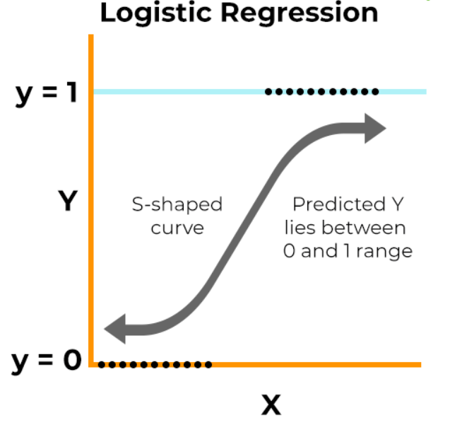
Figure 1: Logistic Regression Explanation Figure (Source: [7])

4.2 Decision Tree
Decision Tree is a non-linear supervised learning algorithm that splits the dataset into subsets based on feature values. It builds a tree-like structure where each internal node represents a decision rule, and each leaf node represents a classification outcome. Decision Trees are easy to interpret and can capture complex interactions between variables, making them suitable for flight delay prediction [2][4]. However, it is prone to overfitting, especially with large or noisy datasets.
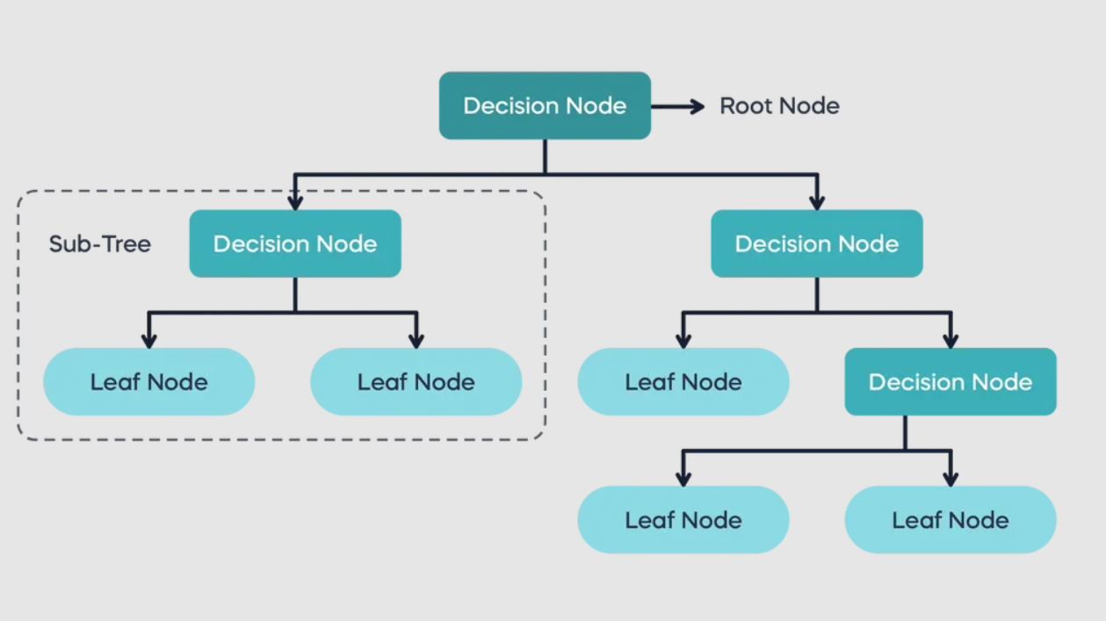
Figure 2: Decision Tree explanation Figure (Source: [8])

4.3 Random Forest
Random Forest is an ensemble learning method that combines multiple Decision Trees to improve prediction accuracy and reduce overfitting. Each tree is trained on a random subset of the data, and the final prediction is obtained by majority voting. This approach increases robustness and is widely used in classification problems involving large and complex datasets such as flight data [2]. However, it is harder to understand how it makes decisions compared to a single decision tree, and it also needs more time and computing power to run.
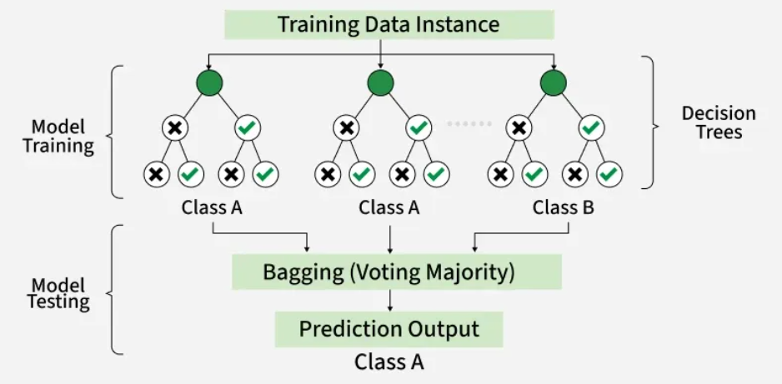
Figure 3: Random Forest Explanation Figure (Source: [9])

4.4 XGBoost
XGBoost is an advanced ensemble learning algorithm. It builds trees sequentially, where each new tree corrects the errors of the previous ones. XGBoost is known for its high performance, scalability, and ability to handle missing data. It is particularly effective in structured datasets and is often used in real-world predictive modeling tasks [3][10]. However, it requires careful parameter tuning and is more complex to implement.

4.5 Model Evaluation Metrics
Because of class imbalance, accuracy alone is not a sufficient evaluation metric.
This project evaluates all models using the following metrics:
- Accuracy: the proportion of correctly classified instances out of all instances.
- Precision: the proportion of predicted delays that are actual delays.
- Recall: the proportion of actual delays that are correctly identified.
- F1-Score: the harmonic mean of precision and recall.
- ROC-AUC: is a score that shows how well a model separates two classes (like delayed flight vs not delayed). It measures how often the model ranks a correct answer higher than an incorrect one.

4.6 Handling Class Imbalance Using Class Weights
Flight delay datasets are typically imbalanced, because on-time flights are more frequent than delayed ones. This will make the models biased toward the majority class and reduce the performance in detecting delays [2][3]. To address this issue, class weighting is applied during model training by assigning higher weights to the minority class and lower weights to the majority class. This helps the model focus more on correctly predicting delayed flights.

5. Literature Review

5.1 Overview of Selected Studies
5.1.1 Airline Flight Delay Prediction Using Machine Learning Models.
Flight delays are gradually increasing and bring more financial difficulties and customer dissatisfaction to airline companies. To resolve this situation, supervised machine learning models were implemented to predict whether a flight will be delayed using historical flight data from JFK Airport. The main objective of the study is to compare multiple supervised classification models and identify the most effective approach for delay prediction. Since the dataset is imbalanced, with far more non-delayed flights than delayed ones, this issue is handled by using weighted evaluation metrics to ensure fair performance measurement across classes. Seven algorithms are evaluated, including Logistic Regression, KNN, SVM, Decision Tree, Random Forest, and Gradient Boosting, using accuracy, precision, recall, and F1-score. The key findings show that tree-based models, particularly the Decision Tree, achieve the best performance with the highest accuracy (0.9778), while KNN performs the worst. Overall, the study concludes that ensemble and tree-based methods are more reliable for predicting flight delays compared to simpler classification models [2].
5.1.2 Predictive Modeling of Flight Delays at an Airport Using Machine Learning Methods.
This study addresses the problem of predicting flight delays exceeding 15 minutes at a Turkish airport, which negatively affect airline efficiency and passenger satisfaction. The authors propose a machine learning-based approach using a dataset of over 40,000 flights collected over three years, including both operational and weather-related features. After preprocessing the data using one-hot encoding and handling class imbalance with SMOTE, several models were developed and compared, including Logistic Regression, Naïve Bayes, ANN, Random Forest, XGBoost, CatBoost, and LightGBM. The main objective was to evaluate different machine learning techniques for binary flight delay prediction and examine the impact of weather data and data balancing methods. The results show that XGBoost, CatBoost, and LightGBM achieved the best performance, with around 80% accuracy, while XGBoost provided the highest recall. SMOTE improved recall in some cases but did not consistently enhance overall performance, and weather features had limited influence compared to operational variables. Feature analysis using SHAP indicated that scheduled time, passenger number, distance, and weather conditions were the most important predictors of delays [3].
5.1.3 Flight delay prediction: Evaluating machine learning algorithms for enhanced accuracy.
In this study published in PLOS One (2025), the authors examined how different machine learning algorithms can be used to predict flight delays, with a strong focus on handling class imbalance in the dataset. They worked with a large Kaggle dataset containing more than 4 million flight records collected between 2018 and 2022. Delays were grouped into three categories: small (less than 15 minutes), medium (15–45 minutes), and large (45 minutes or more). The researchers applied several preprocessing steps, including feature engineering, selecting the top 25 most important features, MinMax scaling, hyperparameter tuning, and stratified 10-fold cross-validation. Since flight delay data is typically imbalanced, they also used three resampling techniques Random Oversampling (ROS), SMOTE, and ADASYN to improve model performance. The models tested were Decision Tree, Random Forest, Support Vector Classifier (SVC), Logistic Regression, K-Nearest Neighbors (KNN), and Naïve Bayes. Their performance was evaluated using Accuracy, F1-score, MCC, and ROC-AUC [4].
The results showed that Random Forest combined with Random Oversampling, and Decision Tree combined with SMOTE, performed the best, both achieving 90% accuracy and an F1-score of 0.91. SVC and Naïve Bayes also produced strong results, while KNN had the weakest performance among the tested models. Statistical tests, including the paired t-test and McNemar test, confirmed that the differences in performance were statistically significant. Overall, the study highlights the importance of addressing class imbalance and applying proper feature engineering techniques, and it shows that ensemble methods like Random Forest are especially effective for multiclass flight delay prediction.
5.1.4 Integrating multiple data sources for improved flight delay prediction using explainable machine learning.
In this study published in Research in Transportation Business & Management (2024), the authors developed a comprehensive data science framework to predict and analyze flight delays at Santiago Airport (SCL) in Chile. The research focuses on the integration of heterogeneous data sources, including operational flight data, airport-specific attributes, geographic information, and real-time weather data from both origin and destination locations. To address the "black-box" nature of traditional predictive models, the researchers implemented an Explainable Artificial Intelligence (xAI) methodology. The preprocessing pipeline involved data fusion from multiple sources, feature selection, and the training of several machine learning algorithms, including Logistic Regression, Linear Discriminant Analysis (LDA), Decision Trees, Random Forest, and Support Vector Machines (SVM).
The results identified Linear Discriminant Analysis (LDA) as the most effective model for this specific dataset, providing a robust balance between predictive accuracy and computational efficiency. To gain deeper insights into the causes of disruptions, the study applied SHAP (SHapley Additive exPlanations) and Sobol Sensitivity Analysis to quantify feature importance. The analysis revealed that the most critical factors influencing flight delays were the international flight status, average temperature at the destination airport, local wind speed, and the ambient temperature at the departure airport. Overall, the study highlights that combining multi-source data with explainable AI techniques not only improves prediction performance but also provides actionable insights for airlines and airport operators to optimize scheduling and resource management [5].
5.1.5 A hybrid machine learning-based model for predicting flight delay through aviation big data.
In this study published in Scientific Reports (2024), the author proposes a novel hybrid methodology to address the challenges of large-scale flight delay prediction using aviation big data. The research utilizes a dataset from JFK International Airport (2023) and introduces a sophisticated pipeline that combines advanced feature selection, clustering, and ensemble optimization. The preprocessing stage employs a combination of ANOVA for initial feature importance analysis and the Forward Sequential Feature Selection (FSFS) algorithm to identify the most influential indicators. To manage the high dimensionality and volume of aviation data, the study implements an enhanced DBSCAN clustering strategy, which partitions the dataset into similar groups to decompose the prediction task into smaller, more manageable sub-problems.
The core of the predictive engine is a Coyote Optimization Algorithm-based Weighted Random Forest (COWRF) model. This novel structure optimizes individual decision trees using the Coyote Optimization Algorithm (COA) to tune split points and assigns weighted values to each tree component to enhance voting accuracy. The results demonstrate that the proposed hybrid approach achieves an average accuracy of 97.2%, representing a significant improvement over baseline ensemble methods and previous deep learning architectures like CNN-LSTM. Specifically, the integration of clustering reduced processing time by 39.17%, while the COA-driven optimization increased model accuracy by 5.3% compared to conventional Random Forest models. Statistical validations and cross-validation results confirm that the proposed framework is highly effective for real-time, large-scale aviation scheduling and planning applications [6].

5.2 Comparative Summary Table

Table 1: Literature Review Comparative Table
Ref. | Year | Dataset, Country | Models Used | Best Result | Imbalance Handling
[2] | 2021 | JFK Airport,  USA | LR, KNN, GNB,  DT, SVM, RF, GBT | DT: 97.78% accuracy | Weighted metrics
[3] | 2024 | Turkish Airport, Turkey | LR, NB, ANN, RF, XGBoost, CatBoost,  LightGBM | XGBoost: ~80% accuracy, highest recall | SMOTE
[4] | 2025 | Kaggle Dataset, USA  (2018-2022) | DT, RF, SVC, LR,  KNN, NB | RF + ROS: 90% accuracy | ROS, SMOTE, ADASYN
[5] | 2024 | Santiago Airport (SCL),  Chile | LR, LDA, DT, RF, SVM | LDA: best accuracy | Feature  Selection+SHAP
[6] | 2024 | JFK Airport,  USA (2023) | COWRF (hybrid:  DBSCAN + COA + RF | COWRF: 97.2% accuracy | ANOVA + FSFS  Feature selection

6. References
[1] B. Zou and M. Hansen, “Flight delay impact on airfare and flight frequency: A comprehensive assessment,” Transportation Research Part E: Logistics and Transportation Review, vol. 69, pp. 54–74, 2014. doi: 10.1016/j.tre.2014.05.016. Available: https://www.researchgate.net/publication/263472147_Flight_delay_impact_on_airfare_and_flight_frequency_A_comprehensive_assessment

[2] Y. Tang, “Airline Flight Delay Prediction Using Machine Learning Models,” 2021 5th International Conference on E-Business and Internet (ICEBI), Singapore, 2021. doi: 10.1145/3497701.3497725. Available: https://dl.acm.org/doi/10.1145/3497701.3497725

[3] I. Hatipoglu and O. Tosun, “Predictive Modeling of Flight Delays at an Airport Using Machine Learning Methods,” Applied Sciences, vol. 14, no. 13, 2024, Art. no. 5472. doi: 10.3390/app14135472. Available: https://www.mdpi.com/2076-3417/14/13/5472

[4] S. A. A. AlBassam and D. N. AlShahrani, “Flight delay prediction: Evaluating machine learning algorithms for enhanced accuracy,” PLOS One, vol. 20, no. 1, 2025, Art. no. e0335141. doi: 10.1371/journal.pone.0335141. Available: https://journals.plos.org/plosone/article?id=10.1371/journal.pone.0335141

[5] J. Pineda-Jaramillo, C. Muñoz, R. Mesa-Arango, C. González-Calderón, and A. Lange, “Integrating multiple data sources for improved flight delay prediction using explainable machine learning,” Results in Tourism, Business and Management, vol. 15, 2024, Art. no. 101161. doi: 10.1016/j.rtbm.2024.101161. Available: https://www.sciencedirect.com/science/article/pii/S2210539524000634

[6] M. Dai, “A hybrid machine learning-based model for predicting flight delay through aviation big data,” Scientific Reports, vol. 14, Art. no. 4603, Feb. 2024, doi: 10.1038/s41598-024-55217-z. Available: https://www.nature.com/articles/s41598-024-55217-z

[7] ResearchMate, “Logistic Regression,” [Online]. Available: https://researchmate.net/logistic-regression/. Accessed: May 1, 2026.

[8] 365 Data Science, “Decision Trees in Machine Learning,” 365 Data Science Tutorials. [Online]. Available: https://365datascience.com/tutorials/machine-learning-tutorials/decision-trees/ . [Accessed: May 1, 2026].

[9] GeeksforGeeks, “Random Forest Algorithm in Machine Learning,” GeeksforGeeks, 2025. [Online]. Available: https://www.geeksforgeeks.org/machine-learning/random-forest-algorithm-in-machine-learning/ . [Accessed: May 1, 2026].

[10] GeeksforGeeks, “XGBoost,” GeeksforGeeks. [Online]. Available: https://www.geeksforgeeks.org/machine-learning/xgboost/. [Accessed: May 2, 2026].

